Trustees 2026
Joe Norley
Hi, I’m Joe and I’m very pleased to have been nominated as a Trustee for the Birmingham and Black Country Wildlife Trust.  I’ve lived in Birmingham over a decade and work as an in-house solicitor, advising senior leaders on governance, risk and strategic decision-making. My role involves helping organisations move forward in a way that is both effective and responsible, and I hope to bring that same pragmatic approach to supporting the Trust.  I have a long-standing interest in the natural world and am a beekeeper. Living in a large urban area has made me particularly aware of the importance of local nature - not just for biodiversity, but for health, wellbeing and connection to place. Spending time outdoors with my young family has reinforced how valuable accessible green space is, and how unevenly it can be experienced across communities.  I am particularly drawn to the Trust’s focus on urban nature recovery and its ambition to deliver meaningful, long-term change across Birmingham and the Black Country. I see trusteeship as an opportunity to contribute my skills in governance and strategic thinking to support that work, while helping to ensure nature remains a visible and valued part of everyday life in the region. | 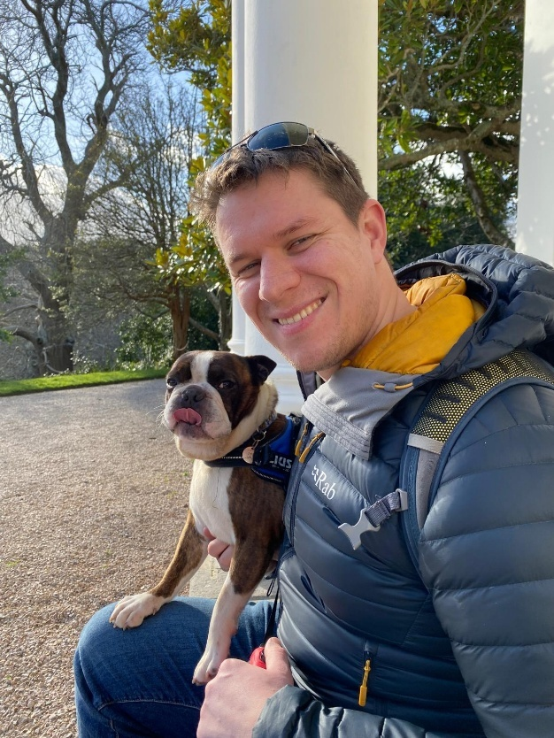
Lucas Howarth
I’m Lucas and I’m hoping to become a Trustee for the Birmingham and Black Country Wildlife Trust. I’ve lived in the region for a long time, first studying at the University of Birmingham and now raising my family here. We spend a lot of our free time outdoors walking the local canals, parklands, and woodlands, and having two children, I see every day just how much our wild spaces support our mental and physical wellbeing.  My career has been in finance and sustainability, and I’m currently the Head of Sustainable Investment at a local mutual. In my day-to-day work, I focus on environmental and social factors, ensuring these are considered when investment decisions are made. I’m a big advocate for inclusion within the investment industry and volunteer with both local and national charities. This has included mentoring and judging for WildHearts to help students develop positive environmental and social ideas, and working with Girls Are Investors to improve diversity through webcasts, judging, and presenting directly to undergraduates.  Outside of work, I love to keep busy and active. You’ll often find me helping out at my hockey club, supporting Junior Parkruns, or getting involved with local Scout groups. I feel very passionately about protecting our wild spaces and making sure everyone has the opportunity to experience nature, and I would love to contribute to the Trust's work across our region. | 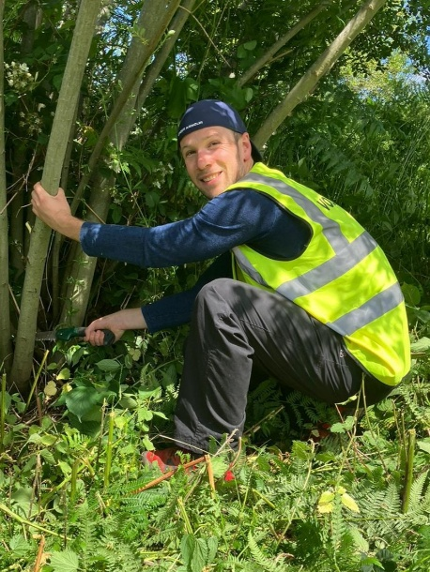
Monique Powell
I have lived in inner-city Birmingham for my entire life and have a deep connection to the city, its communities and the people who call it home. My professional career is centred on supporting mental health and wellbeing, and I currently work as a CBT Psychotherapist within the NHS as well as in private practice. Through these roles, I help individuals develop the skills and resilience needed to improve their mental health and quality of life.  Alongside my clinical work, I founded and lead Trekkers UK, an outdoor community organisation dedicated to widening access to and participation in green spaces, both locally and nationally. Through this work, I have developed initiatives that encourage people from diverse backgrounds to connect with nature, recognising the powerful role that green spaces play in supporting both mental and physical wellbeing. I have experience developing community programmes and securing funding to support their delivery and long-term impact. My work promoting inclusion and access to nature has been recognised nationally, and I have been a finalist in both the National Diversity Awards and the National Park Protector Awards.  I hold MSc degrees in Cognitive Behavioural Psychotherapy and Forensic Psychology, bringing together expertise in mental health, behaviour change and community engagement. I am passionate about ensuring that green spaces are accessible to everyone, regardless of background or circumstance, and believe they have a vital role to play in creating healthier, more connected communities.  As someone who has grown up in Birmingham, I care deeply about the future of our city and the opportunities available to its diverse communities. I am seeking trusteeship with Birmingham & Black Country Wildlife Trust because I want to contribute to creating lasting, positive change for both people and nature. I hope to bring my experience in mental health, community development, fundraising and widening access to green spaces, helping the Trust engage diverse communities and ensure that the benefits of nature are accessible to all, in support of the Trust’s vision and strategic goals. | 